**HOME PAGE**

<!DOCTYPE html>

<html lang="en">

<head>

<meta charset="UTF-8">

<meta http-equiv="X-UA-Compatible" content="IE=edge">

<meta name="viewport" content="width=device-width, initial-scale=1.0">

<title>Website with Login & Registration | Codehal</title>

<style>

header{

position:fixed;

top:0;

left: 0;

width: 90%;

height: 5%;

padding: 20px 90px;

backdrop-filter: blur(15px);

display: flex;

justify-content: space-between;

align-items: center;

z-index:99;

background-color:white;

}

.navigation a

{

position: relative;

font-size: 1.1em;

color:black;

text-decoration:none;

font-weight:500;

margin-left:40px;

}

body{

background:url(./picture.jpg );

background-size: cover;

}

img{

height: 70px;

width: 100px;

}

h1{

text-align: center;

color:whitesmoke;

margin-top: 300px;

}

</style>

</head>

<body>

<header>

<img src="./book logo.jpg" >

<nav class="navigation">

<a href="#">Home</a>

<a href="#">About</a>

<a href="aboutbook.html">Gallery</a>

<a href="next.html">Sign</a>

</nav>

</header>

<h1>“ROSE book shop."

</h1>

<footer></footer>

</body>

</html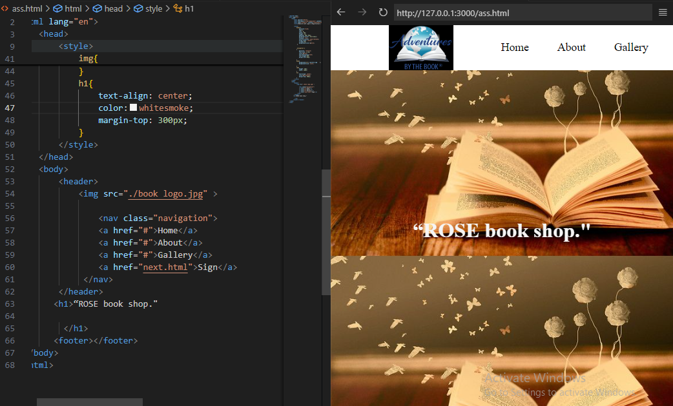

**GALLERY PAGE**

!DOCTYPE html>

<html lang="en">

<head>

<meta charset="UTF-8">

<meta name="viewport" content="width=device-width, initial-scale=1.0">

<title>Book Gallery</title>

<link rel="stylesheet" href="styles.css">

</head>

<body>

<h2>Book Gallery</h2>

<div class="gallery">

<div class="book">

<img src="WhatsApp Image 2024-07-27 at 21.52.56_7f26f373.jpg" alt="Book 1">

<h3>The Book Of Life</h3>

<p>Author: J.Krishnamurti</p>

</div>

<div class="book">

<img src="WhatsApp Image 2024-07-27 at 21.52.57_99083001.jpg" alt="Book 2">

<h3>The Girl Who Knew Too Much</h3>

<p>Author: Vikrant khanna</p>

</div>

<div class="book">

<img src="WhatsApp Image 2024-07-27 at 21.52.57_a05abb20.jpg" alt="Book 3">

<h3>Something I Never Told You</h3>

<p>Author: Shravya Bhinder</p>

</div>

<!-- Add more book divs as needed -->

</div>

<style>body{

background:url(./picture.jpg );

background-size: cover;

}

img{

height: 70px;

width: 100px;

}

</style>

<script src="script.js"></script>

</body>

</html>

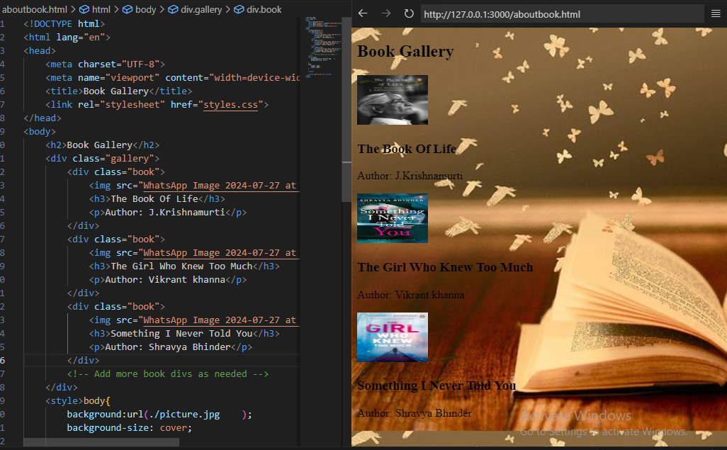

**SIGN IN PAGE**

<!DOCTYPE html>

<html lang="en">

<head>

<meta charset="UTF-8">

<meta name="viewport" content="width=device-width, initial-scale=1.0">

<title>Document</title>

<link rel="stylesheet" href="https://fonts.googleapis.com/icon?family=Material+Icons">

<style>

* {

margin: 0;

padding: 0;

font-family: 'Poppins', sans-serif;

box-sizing: border-box;

}

.container {

width: 100%;

height: 100vh;

display: flex;

justify-content: center;

align-items: center;

position: relative;

}

body {

background: url(./3320d62cb3505de7fa982bef3c708d12.jpeg);

background-size: cover;

}

.form-box {

background: rgba(255, 255, 255, 0.3);

padding: 40px;

border-radius: 10px;

box-shadow: 0 0 10px rgba(0, 0, 0, 0.1);

text-align: center;

backdrop-filter: blur(15px);

}

.form-box h1 {

margin-bottom: 20px;

}

.input-group {

display: flex;

flex-direction: column;

gap: 15px;

}

.input-field {

position: relative;

display: flex;

align-items: center;

}

.input-field i {

position: absolute;

left: 10px;

font-size: 1.2em;

color: #666;

}

.input-field input {

width: 100%;

padding: 10px 10px 10px 35px;

border: 1px solid #ccc;

border-radius: 5px;

text-align: center;

}

.input-field button {

width: 100%;

padding: 10px;

border: none;

border-radius: 5px;

background-color: gray;

color: white;

font-size: 1em;

cursor: pointer;

transition: background-color 0.3s;

}

.input-field button:hover {

background-color: #505050;

}

body{

background:url(./picture.jpg );

background-size: cover;

}

img{

height: 70px;

width: 100px;

}

</style>

</head>

<body>

<div class="container">

<div class="form-box">

<h1>Sign In</h1>

<form action="">

<div class="input-group">

<div class="input-field">

<i class="material-icons"></i>

<input type="text" placeholder="Name" required>

</div>

<div class="input-field">

<i class="material-icons"></i>

<input type="email" placeholder="Email" required>

</div>

<div class="input-field">

<i class="material-icons"></i>

<input type="password" placeholder="Password" required>

</div>

<div class="input-field">

<button type="submit">Submit</button>

</div>

</div>

</form>

</div>

</div>

</body>

</html>

